**DAILY ONLINE ACTIVITIES SUMMARY**

|  |  |  |  |  |  |  |  |
| --- | --- | --- | --- | --- | --- | --- | --- |
| **Date:** | 04/06/2020 | | | | **Name:** | AMBIKA V | |
| **Sem & Sec** | 4th Sem Section'A' | | | | **USN:** | 4AL18CS005 | |
| **Online Test Summary** | | | | | | | |
| **Subject** | | Micro controller and embedded system | | | | | |
| **Max. Marks** | | **20** | | **Score** | | **14** | |
| **Certification Course Summary** | | | | | | | |
| **Course** | JAVA PROGRAMMING | | | | | | |
| **Certificate Provider** | | | greatlearning academy | **Duration** | | | 3.5 hrs |
| **Coding Challenges** | | | | | | | |
| **Problem statement 1:** write a java program to read three integer values from the keyboard and find the sum of the values. Declare a variable "sum" of type int and store the result in it.  **Problem statement 2:** Write a C++ program to find the missing number in array. | | | | | | | |
| **Status:** completed | | | | | | | |
| **Uploaded the report in Github** | | | | yes | | | |
| **If yes Repository name** | | | | https://github.com/ambika0202/lockdown-coding- | | | |
| **Uploaded the report in slack** | | | | yes | | | |

**ONLINE TEST DETAILS:**

MES test was scheduled from 02:00 pm to 02:30pm .The portion for the IA was 3rd module there were 20 questions and the time assigned was 30minutes the questions were mcq type.

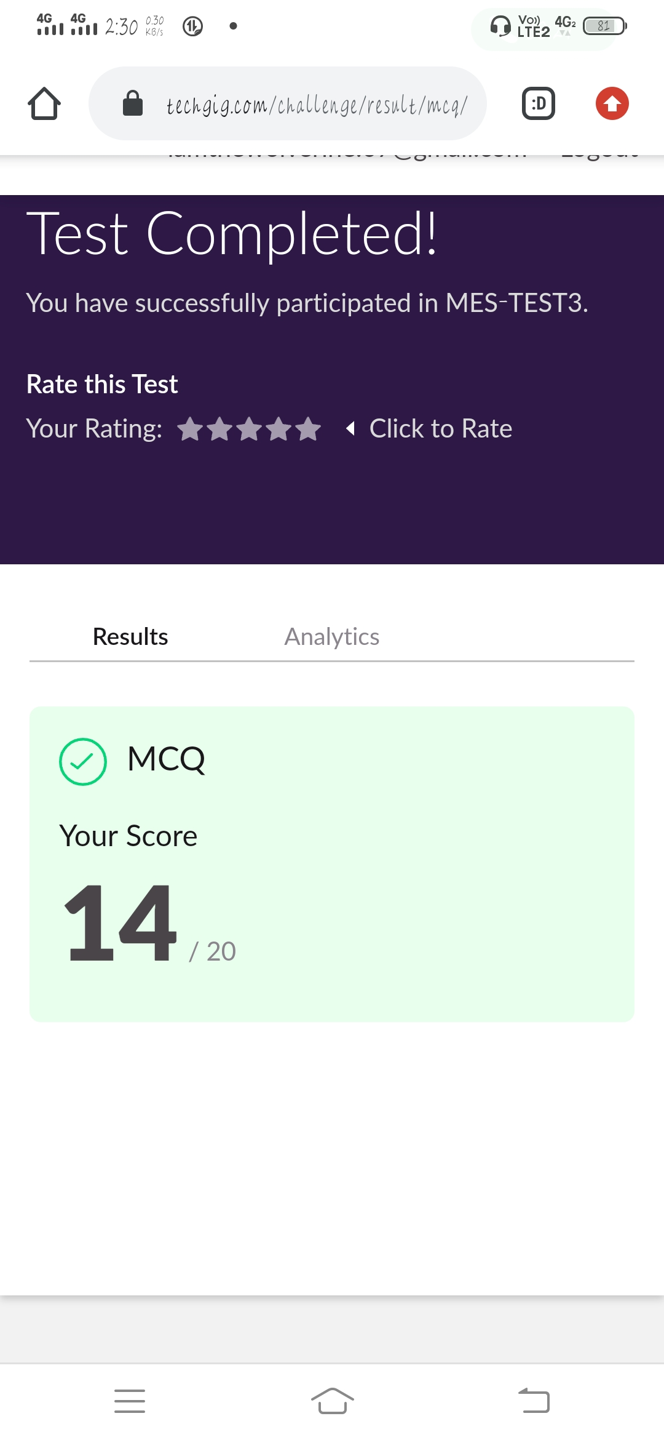

**CERTIFICATION COURSE DETAILS:**

**Name of the course**: Java Programming

**Certificate Provider**: Great Learning Academy

Today I started a new topic and got to know about the arrays used in Java programming.

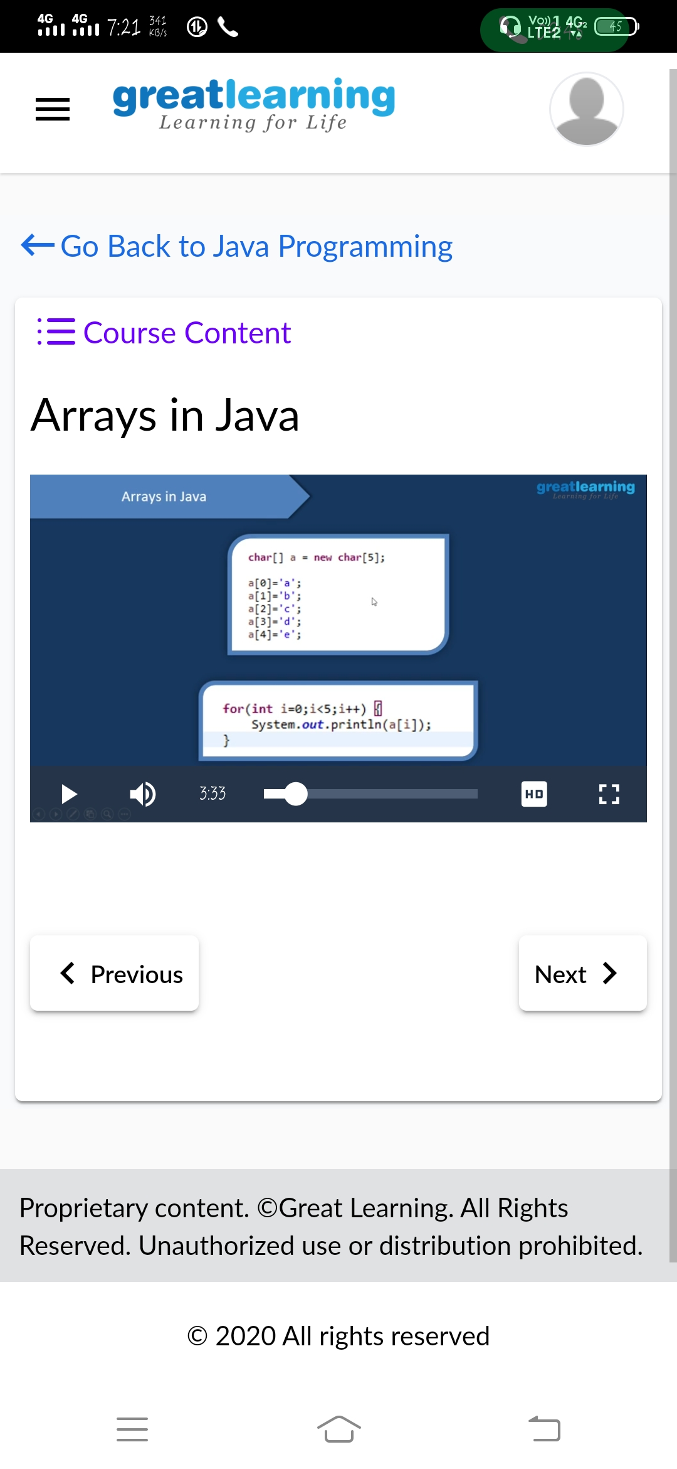

**CODING CHALLENGES DETAILS**:

**Problem statement 1:** write a java program to read three integer values from the keyboard and find the sum of the values. Declare a variable "sum" of type int and store the result in it.

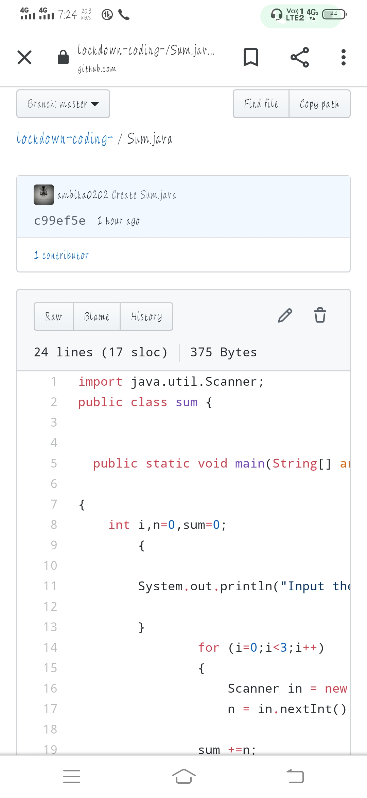

**Problem statement 2:** Write a C++ program to find the missing number in array.

